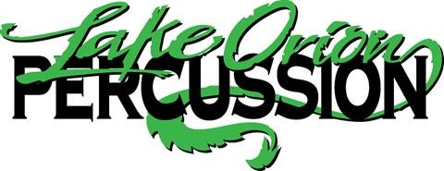
2020 Lake Orion Percussion Sponsorship Letter

Member Name_____________________________ Member Phone Number________________

The 2020 Lake Orion Winter Percussion Group will be performing at local competitions and State Finals. This year they will be traveling to Indianapolis, to compete in the WGI regional competition. They will also be traveling to Dayton Ohio, to compete in the WGI World Championship Competition. Last year, their talent level got them bumped to a more competitive class. The Lake Orion Percussion Group has qualified for World semifinals the last 4 years and were World Champs in 2015. The performance season takes many levels of financial support, for staffing, design, props, uniforms, equipment, transportation, lodging and other operational expenses. We start every winter season with a fundraising goal of at least $10,000. This year, due to additional costs of traveling to Indy, our goal is at least $15,000. Students are asked to participate in many fundraising activities
For 2020, the student fair share fundraising goal for each student will be $300
One of the best and most effective ways students can raise money, is by acquiring sponsorships that goes directly towards to the students in the program. With a sponsorship, 50% of the funds raised goes directly to the individual student’s fees and 50% goes to the entire ensemble and the cost for the 2020 season. Any amount is greatly appreciated. You can be an elite sponsor for a $250 donation. As an elite sponsor, your business will receive their logo on our show shirts, worn to all competitions and school days before we compete. Your business logo will be placed on a banner that is hung at our public performances. You will be personally invited to attend these performances. You will also be advertised on our Facebook pages and Winter Percussion website. If you would like to make a donation or become a sponsor, please fill out the additional portion of this letter with a check made out to LOBB. It can be returned to the student who presented this letter or mail it to the address listed below. Thank you for your generous support!

2020 Lake Orion Percussion Sponsor Form
Lake Orion Percussion thanks you for your generosity and support.
Lake Orion Percussion is under the Lake Orion Band Boosters, which is 5013c organization. This makes your donation tax deductible. Please mail payment and this completed form to:
Lake Orion Band Boosters
Att; Lake Orion Percussion
PO Box 93
Lake Orion, MI 48362
Checks Payable to LOBB

Sponsor Name__________________________________________ Phone________________________
Sponsor Address___________________________________________________________________
City___________________________________ State_____________ Zip ________________________
Email (opt.) ________________________________________________________
Other information (if needed) ____________________________________________________________
Amount of donation $_______________________ (checks payable to LOBB)

Band member securing sponsorship _____________________________________________

Email all logo and artwork to
lop@lodragonbands.org
Logo’s or art work are due no later than January 10, 2020
Company Logo should be submitted as a vector file that’s end with either .ai or .eps.
LOBB Tax ID # 38-6094471

